

**FUNCTIONAL REQUIREMENTS**

Product Name: bookbird Online bookstore (Frontend)

Prepared by: Raveen Jayasooriya

Date: Feb 11, 2023

Overveiw

<http://localhost/BookStore-master> is a website for an extensive collection of books, stationery and magazines. Not only a “one-stop shop” for book lovers but also an interactive and innovative destination designed to make it fun and exciting to discover and shop for new books and gifts online. Buy books online and get them delivered right to your door, Sri Lanka's Premier Online Bookseller**bookbird** Bookshop  http://localhost/BookStore-master

**Sarasavi online bookstore Frontend**

This Document is intended to be uses as an introduction to the Sarasavi online bookstore default store front. The store front reveals how the customer view and interacts with the store.

# System Scope

The Online Book Store is a web based application intended for online retailers. Scope of this document is to satisfy the requirements, clearly identifying the information needed by the user, the source of the information and outputs expected from the system.

# Tools/Platform, Hardware and Software Requirement specifications.

**Tools**

* Dreamweaver
* CS6
* XAMPP MySQL
* Platform
* Microsoft Windows 10

**Hardware Requirement Specification**

|  |  |  |  |
| --- | --- | --- | --- |
| Client Machine | | Client Machine | |
| HDD | 200MB | HDD | 320GB |
| Processor | Pentium 4 or newer processor that supports SSE2 | Processor | Dual Core or newer processor |
|  |  |  |  |
| Memory | 512 MB | Memory | 2 GB |
| Browser | Any standard browser with JavaScript interpreter |  |  |
| Client side mark up / scripting languages | HTML, Javascript |  |  |
|  |  |  |  |

As a tester for an online bookstore, your role would involve ensuring that the system meets the functional requirements and operates as intended. Here are some functional requirements you can focus on while testing the online bookstore:

* User Registration and Authentication:
  + Test the registration process to ensure users can create new accounts successfully.
  + Verify that users can log in with their credentials and access their accounts.
  + Test password reset and recovery mechanisms to ensure they function properly.
* Product Catalog:
  + Verify that the book details (title, author, price, description) are correctly displayed.
  + Test the search functionality to ensure it returns accurate results based on different criteria.
  + Check the filtering and sorting options to confirm they work as expected.
* Shopping Cart:
  + Test adding books to the shopping cart and verify that they appear correctly.
  + Validate the ability to modify quantities or remove items from the cart.
  + Ensure that the total cost is calculated accurately.

**Navigating the shop**

The Online bookstore default theme makes navigating shop’s products easily accessible to its customers.

**Home Page**

A home page) is the main web page of a website. The term may also refer to the start page shown in a web browser when the application first opens. Usually, the home page is located at the root of the website's domain or subdomain. For example, if the domain is https://www.sarasavi.lk/, the home page is likely located at <https://www.sarasavi.lk/>.

**The header**

The header will be displayed at the top of the page ,on every page of the store ;not just the home page.

The header has the following navigation options:

* Store Logo : Clicking on this logo will direct the customer back to the home page of the store.
* Shoping Cart : Displays the number of items purchased , and the total price of the order .Clicking on the button will containing all of products added to the cart and an options to “View Cart” or “Checkout”
* Search Box : The customer can type in search box to search for a product within the store’s product categories.

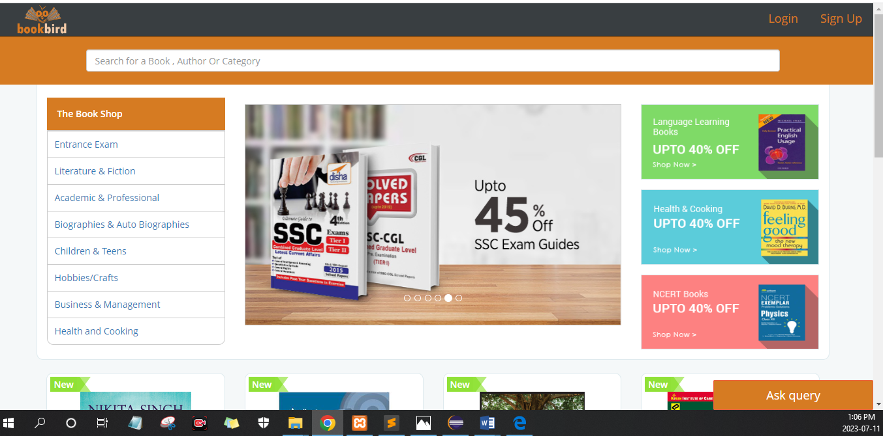**Slideshow**

The slideshow displays several products banners of your choice by alternating the images in a slideshow. After a certain amount of time, one banner will shift to the next banner. Banners in this slideshow are useful for highlighting certain products to be easily accessible by the customer. When the banner is clicked on, the customer will be directed to the product on the banner’s page.

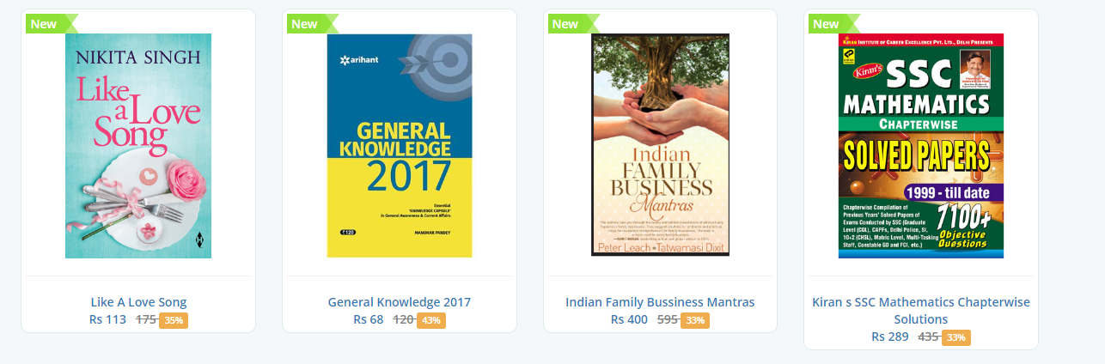**New products**

The Online bookstore gives you’re the options of featuring specific products of their choosing on the home page.

The New Products section includes the products image, name, price and an options to add the product directly to the Shopping Cart.

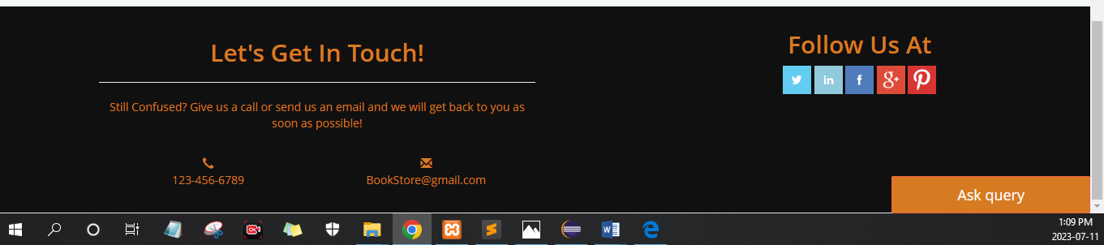**Footer**

The footer is located at the bottom of every page, not just the Home page.This block f miscellaneous links is useful in sorting relevant pages for the customer that may not logically sort anywhere else.

The organizational scheme of the footer can be divided into the following sections :

* About US
* 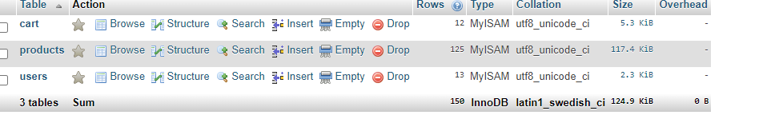Terms of services
* Branch Network
* Contact Us
* FAQ Payment policy
* Shipping and returns
* Privacy and Cookies Policy
* Coupon T&C
* Payment Methods
* Shipping Methods

Structure

## **Schema/Database Design**

Products

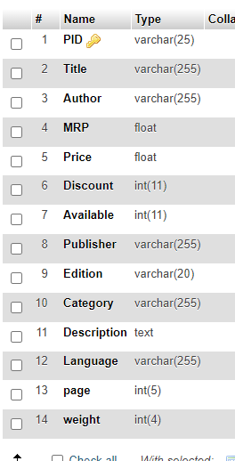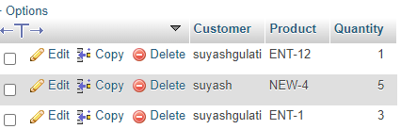

Users

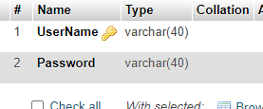

**Login to continue**

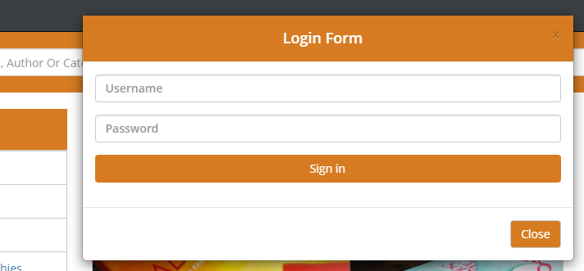

**Registration Page**

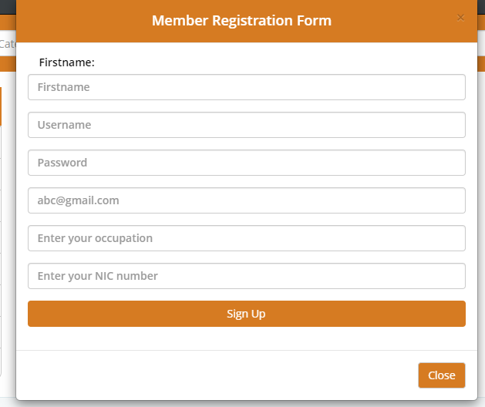

**Search book**

